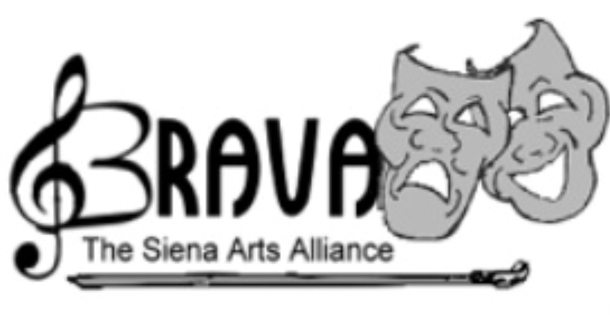

BRAVA: The Siena Arts Alliance is a group of parents, teachers, staff, alumnae and friends of Saint Agnes, working together to support the Fine Arts Department at The Academy.

We would love to have you join us in our endeavors as we work with the Visual Arts, Vocal Music and Theatre Departments in leading the young ladies of St Agnes in the ways of the Fine Arts.

Just a few ways we provide support:

Theatre: selling tickets at all productions, providing dinner to the students on dress rehearsal nights, purchasing theatre needs such as bus rentals for their community tour, microphones, etc.

Visual Arts: providing refreshments at The Altered Book Show and Calliope Café, catering dinner for the Senior Art Show, purchasing Art supplies for the students, etc.

Vocal Music: hand out programs and accept donations for the department at all vocal music events, purchase sheet music for the students, etc.

Fund a BRAVA scholarship and Fine Arts Banquet, promote all events and MORE!

Please consider joining us by filling out the membership form!

Sincerely,

Tara Brady (Hazel ’20 & Adelina ’23)
BRAVA President
832-381-7842
bradybase@aol.com

